**A ONE-STOP HEARING AID CENTRE**

**Philosophy**

We are passionate about hearing health, and work with students, hearing societies, government bodies to promote hearing health. Dr Lynne Lim has started the Master of Audiology program in NUS for training of audiologists, developed hearing tests via home telephone delivery, set up minivans that go to the community centres for hearing tests and hearing aid fittings for the elderly who find it hard to access hospital care. She also continues to work on research into devices enabling grommet tube insertions without general anesthesia, and bioabsorbable grommet tubes that would not overstay their use.

The centre is continuously looking into ways to deliver better hearing services. It employs full time professional audiologists committed to making accurate diagnoses, managing complex cases together with the ENT doctor, and ensuring patient satisfaction. For example, we provide home visits services for patients needing a more private or convenient form of support. We have made available many brands and models of hearing aids, bone anchored, middle ear and cochlear implants. We keep at the forefront of the most current technology, like exploring even teleservice for hearing aids to decrease the burden of follow up. The centre further provides comprehensive balance services to complement the care of the hearing, tinnitus and balance affected patient.

**What happens at the visit**

If a hearing aid is chosen solely based on cosmesis or only a certain brand is shown, the performance and satisfaction may not be optimal. It is not the most expensive aid that works the best, nor the smallest. Individual preferences, hearing experience and medical history differs.

At our Centre, a full ear examination is first done by the ENT doctor to exclude sinister ear conditions like deep seated infections and tumors. Ear wax may need to be removed first. Related symptoms like tinnitus and giddiness often need to be managed by the ENT together for optimal hearing function.

This is followed by complete hearing tests tailored for newborns, toddlers, young children and adults. When needed, a hearing aid evaluation and hearing aid trials with different brands is then done. The centre carries a very wide range of brands and models of hearing aids, is outfitted with sound-proof hearing test and sound-treated fitting rooms and have 2 dedicated full-time professional audiologists who speak different languages and carefully follow up on the changing needs of the hearing aid user. FM systems assistive listening devices are recommended to further optimize performance in school or noisy environments. With disease progression or depending on personal needs and lifestyle, sometimes even the best hearing aid may not be enough. Surgery may then need to be discussed. Multidisciplinary care is coordinated for patients with speech therapy, auditory verbal therapy, development assessment and educational assessment needs. This allows a one-stop hearing service for the holistic care of families and patients.

**HEARING AID PACKAGE**

**Brands of Hearing Aids at Our Centre**

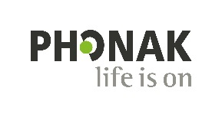

**The Joy of New-Technology Hearing Aids**

1. **Noise-cancellation**: Differentiates speech from noise, and manages wind, car & background noise.
2. **Directional microphones**: Digitally focus on the specific sound source that you want to hear. 
3. **Reduced feedback**: Less squealing sounds, less need to reduce the volume. 
4. **Tinnitus relief**: Hearing improvement & sound therapy customised to reduce ringing in the ears.
5. **Connectivity**: incoming handphone calls & TV sounds wirelessly directly & discretely sent to the HA without needing to put the phone to the ear; control volume of HA from handphone. 
6. **Different styles**: For different severity of HL, comfort, dexterity & personal preference.

Behind or fit in your ear

**Categories of Hearing Aids**

**Custom-made (CM)** hearing aids are tailored to each individual’s ear canal size and shape. These can be Completely-in-the-canal (CIC), In-the-canal (ITC) and In-the-ear (ITE), largely depending on the degree and type of hearing loss too. Other factors like battery life, user’s dexterity and hearing aid features should be considered.

**Behind-the-ear (BTE)** hearing aids have the internal components housed in a casing which sits behind the ear; connected by a tiny tube to ear molds sited in the ear canal. As the ear canals of younger children are still growing, traditional BTE hearing aids are best as they can change just the earmold component with growth, and continue using the same hearing aid. Receiver-in-the-canal (RIC) hearing aids are smaller than traditional BTE, with the receiver component separately sited in the ear canal. This makes it very popular amongst adults as it combines cosmesis with great sound amplification.

Different colors can be chosen to match hair and skin colors. Though some want them camouflaged, many others also choose bright colors and patterned ones to match their moods and outfits – an expression of their self and personality like eye glasses.

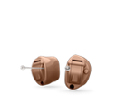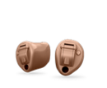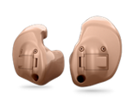 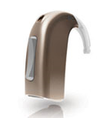 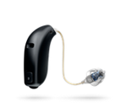

**Basic Components of a Hearing Aid**

1. The **microphone** picks up different sounds and converts them into electrical signals. A directional microphone focuses on sounds from a single direction, important when listening to speech in the presence of noise. An omnidirectional microphone picks up sounds from all directions, to locate where a sound is coming from.
2. The **amplifier** then converts the electrical signals from the microphone into digital signals. These can be tuned according to the wearer’s hearing loss and hearing needs.
3. The **receiver** plays the amplified sound to the ear.

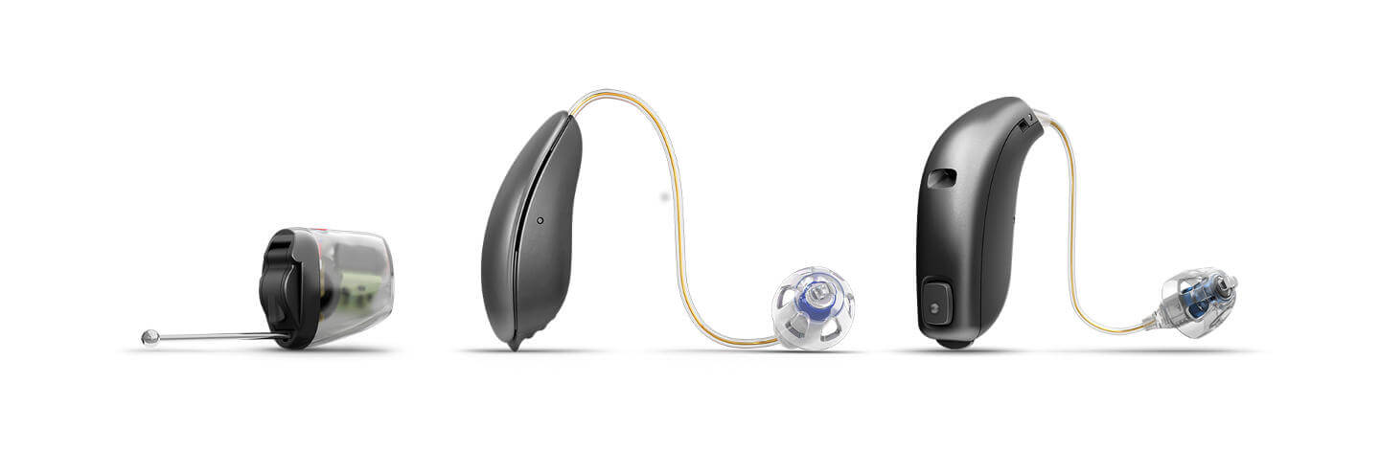

Microphone

Receiver

Receiver

Amplifier

**Analog vs Digital Hearing Aids**

Older analog hearing aids mainly converts sounds into electrical signals and makes the signals louder. In contrast, newer digital hearing aids use complex sound processing technology to first convert sounds into numerical codes which contain information about the loudness and pitch of a sound. The sounds can then be adjusted based on the users’ specific hearing loss patterns and hearing needs in different listening environments eg noisy meetings, listening to music etc. It can be programmed to improve speech recognition in noise, and to reduce background noise.