VERTIGO & Ear-Related Giddiness
When the Room Starts Spinning
Vertigo is a sensation of the room spinning round, and more specific for ear-related giddiness. Non-specific giddiness more commonly due to none ear disorders are variously described as feeling woozy, faint, swaying or light-headed. However, central brain disorders like strokes can cause vertigo, and non-specific swaying giddiness can be ear related too. The first 24 hours when giddiness happens are frightening for patients, and that is also when an accurate diagnosis is most important.
Giddiness are common complaints in older patients, though they can hit at any age, even young children. About 30-50% of giddiness are due to ear problems. They dramatically restrict one’s lifestyle and activities, as the attacks are unpredictable and thus depressing, and they increase accidents and falls.
Non-ear related causes (~70% of cases) include medications, dehydration or overheating, low sugar or anaemia, poor vision, orthopaedic and heart disease, strokes, brain tumors/ injury and sedentary lifestyles. Children may have giddiness from migraine attacks without headaches, or minor epileptic attacks. Some patients have more than one cause for the giddiness, thus careful evaluation is important.
The ear balance system consists of 3 semi-circular canals that detect rotational head movement; and 2 sacs that detect horizontal movement and vertical acceleration.
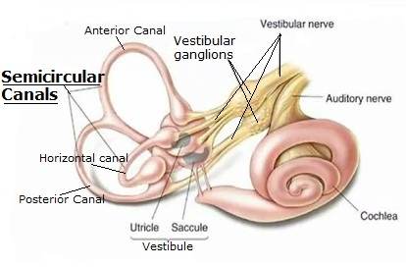
Common Causes of Ear-related Giddiness:
- Benign Paroxysmal Positional Vertigo (BPPV): 50% of older adults experience it. In younger patients, it usually follows infections and head injury. A brief intense spinning happens when the patient changes head position (eg getting out of bed, at exercise classes). Though recurrences can be as high as 40%, most resolve with a particle repositioning manoeuvre in the clinic.
- Inner ear inflammation: usually due to virus or bacteria infection, or sudden insufficiency of blood supply to the inner ear
- Middle ear infection: often with flu or cold, or impaired eustachian tube function
- Meniere’s disease: besides vertigo, there are recurrent episodes which may be associated with ringing or fullness in the ear, and hearing loss
- Ear balance nerve disorder: due to a virus infection or tumor
- Perilymph fistula: leak of inner ear fluid, associated with diving, head injury, physical exertion, blast trauma, middle or inner ear surgery or tumor
- Mal de Debarquement syndrome: feeling of continuous bobbing after sea travel
Red Flags for Possible Stroke as a Cause Of Giddiness
- The most severe headache ever
- Deadly Ds : drop attacks, diplopia, dysarthria, dysphagia
- Uncontrollable movement of eyes: bidirectional, vertical skew
- Cranial nerve weakness, numbness
- Loss of control of limb movements and walking

Evaluation of Giddiness at Our Clinic:
- A careful history and simple bedside tests are the most important to clinch a correct diagnosis. Patients may not define their symptoms accurately, or presentations may be unusual. (eg, a patient with BPPV may deny spinning sensations and say that he is only light-headed or feels like falling backwards.)
- Tests for positional vertigo of multiple semi-circular canals will be done in complex cases, as the Dix Hallpike test only tests for the posterior semicircular canal.
- Disorders of neck-spinal, neck-brain circulation and lying-standing blood pressure will sometimes need to be excluded.
- As the balance system is highly complex, our centre have offers a comprehensive battery of different tests for detailed investigations where needed. Besides the traditional Vestibulonystamography (VNG) test, newer tests like Video Head Impulse Test (VHIT) and Vestibular Evoked Myogenic Potential (VEMP) test are also employed. Together, they allow full testing of all semicircular canals, saccule and utricle; differentiate between central brain and ear causes of giddiness; and tests mimicking real-life situations that bring on giddiness better. The rotary chair is useful in rare occasions of bilateral balance problems, but tests only for very low speed movements unlike that of normal daily functioning.
- Careful interpretation of the various tests is made possible with combined clinical ENT and audiologist professional inputs. Eg, an abnormal VNG alone may not mean the ear is the only cause of that patient’s giddiness in a patient with multiple other medical history.
- Special radiology scans eg CT or MRI or angiography scans may be required.

Treatment of Giddiness at Our Clinic
- Oral anti-vertigo and anti-nausea medications for acute giddiness helps.
- Injection of gentamicin or steroids into the middle ear may be useful for some.
- In severe debilitating cases, surgery on the inner ear balance organ is possible.
- For uncompensated ear giddiness, rehabilitation exercise therapy helps.
- Patient education, non-sedentary lifestyles, fall-proofing homes, safe footwear and assistive devices are equally important.
- Multidisciplinary expertise may be tapped to exclude other system disorders eg heart, brain, eye, spinal, geriatrics.
- Research worldwide currently on nanoparticle drug delivery into inner ear and ear balance implants.

VHIT Test

VNG Test
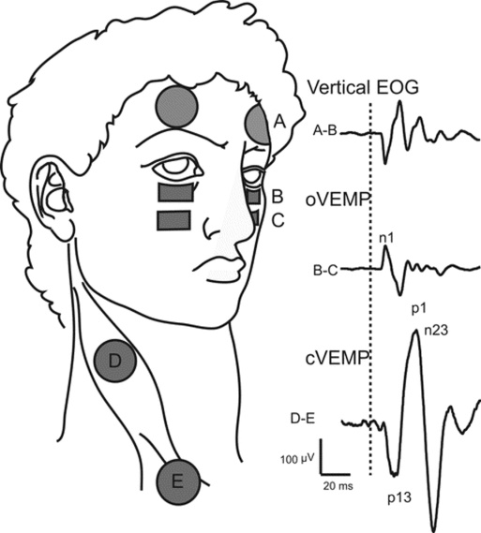
VEMP Test

